Microsoft logo

Robotic Process Automation in a Day

Lab prerequisites 1.1 – How to setup a tenant and create an environment

30 mins

April 2023

Applies to Power Automate Desktop v. 2.31.105.23101 ([more](https://learn.microsoft.com/en-us/power-platform/released-versions/power-automate-desktop))



This document is provided “as-is.” Information and views expressed in this document, including URL and other Internet Web site references, may change without notice. You bear the risk of  
using it. Some examples are fictitious and are for illustration only. No real association is intended  
or inferred. This document does not provide you with any legal rights to any intellectual property in any Microsoft product. You may copy and use this document for your internal reference purposes.

© 2021 Microsoft Corporation. All rights reserved.

# Lab overview

This beginner-level lab gives you hands-on experience designing and developing an end-to-end RPA automation using Power Automate. We’ll show you the steps to build automate in less than a day.

Here’s what you’ll learn:

|  |  |
| --- | --- |
| Power Automate Desktop flows | Create desktop flows that can record and playback manual steps against Win 32 desktop application or website. Learn how to run UI automation in attended or unattended mode. |
|  |  |
| **Integration of Desktop flows with API connectors** | Create a cloud flow that automates an end-to-end business process by connecting the desktop flow and other API cloud services such as Outlook and Microsoft Teams together. |
|  |  |

Be sure to take each prerequisite step in this document before you start any of the labs.

# Pre-requisite task 1: Setup Tenant

As prerequisites for RPA in a Day workshop, you need to have a valid tenant (Azure Active directory) account setup.

|  |
| --- |
| **Important:** If you have been provided with an existing tenant account through Office 365 or Power Automate licensing (prod or trial), you can skip this lab and start from lab #1.2 |
|  |
| **Important:** In the next labs you will be using two accounts:   1. **Work account** to log in to Office 365 tenant (to log in to Office 365 services) 2. **Windows account** (to log in to your computer and to set up a connection) |

If you don’t have an existing tenant account to use, these steps will help you to set up one.

**Prerequisites**: To set up a tenant, you need an existing personal email account (refer to as Microsoft Account (MSA) below) and a cellphone that can receive text message for sign up verification.   
If you don’t have MSA, you can create one on [www.live.com](http://www.live.com). Once you create your MSA, follow the steps below.

1. Open a browser and navigate to <https://products.office.com/en-us/business/office-365-enterprise-e3-business-software>.
2. Select Free trial if you chose the first link, to navigate to trial sign up page.

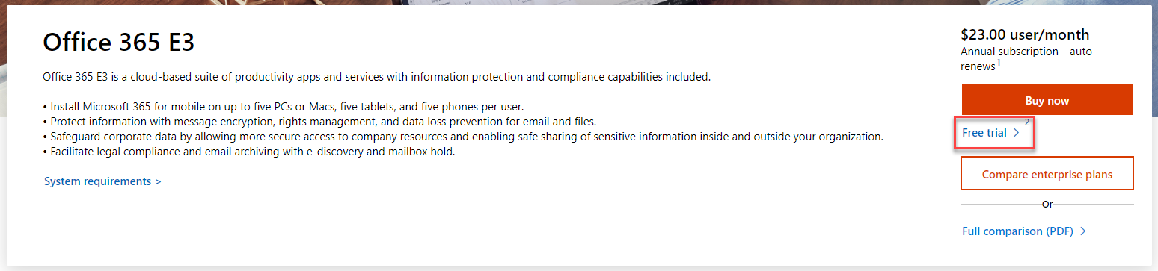

1. Enter your MSA e-mail address and click Next.

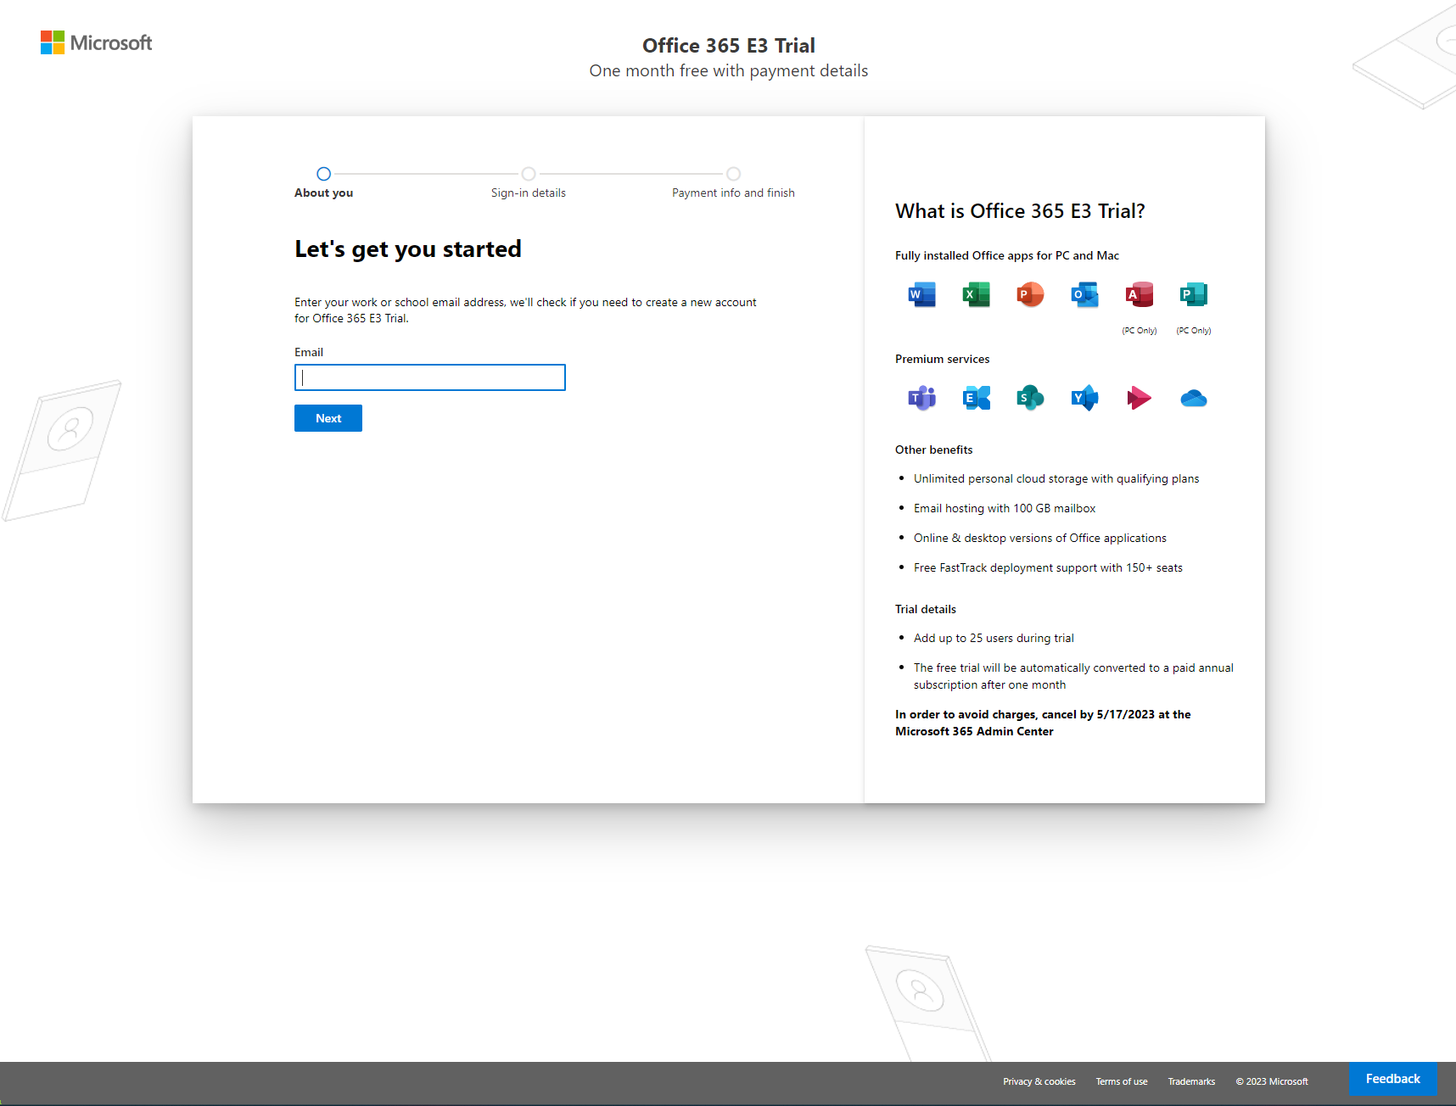

1. Click Set up account.

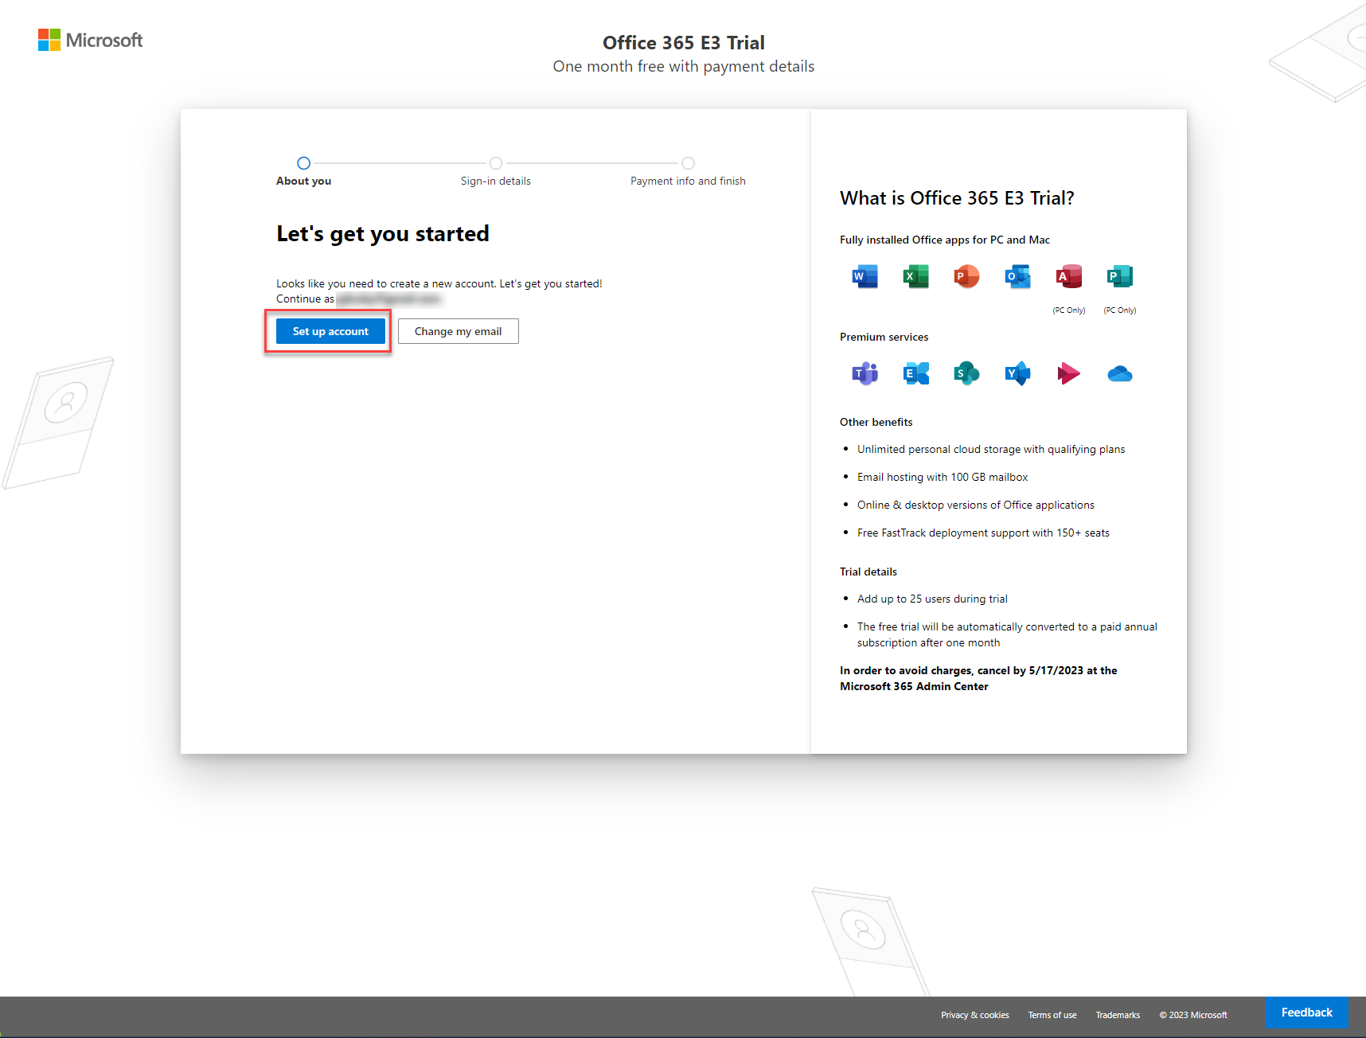

1. Fill in required information and click Next.

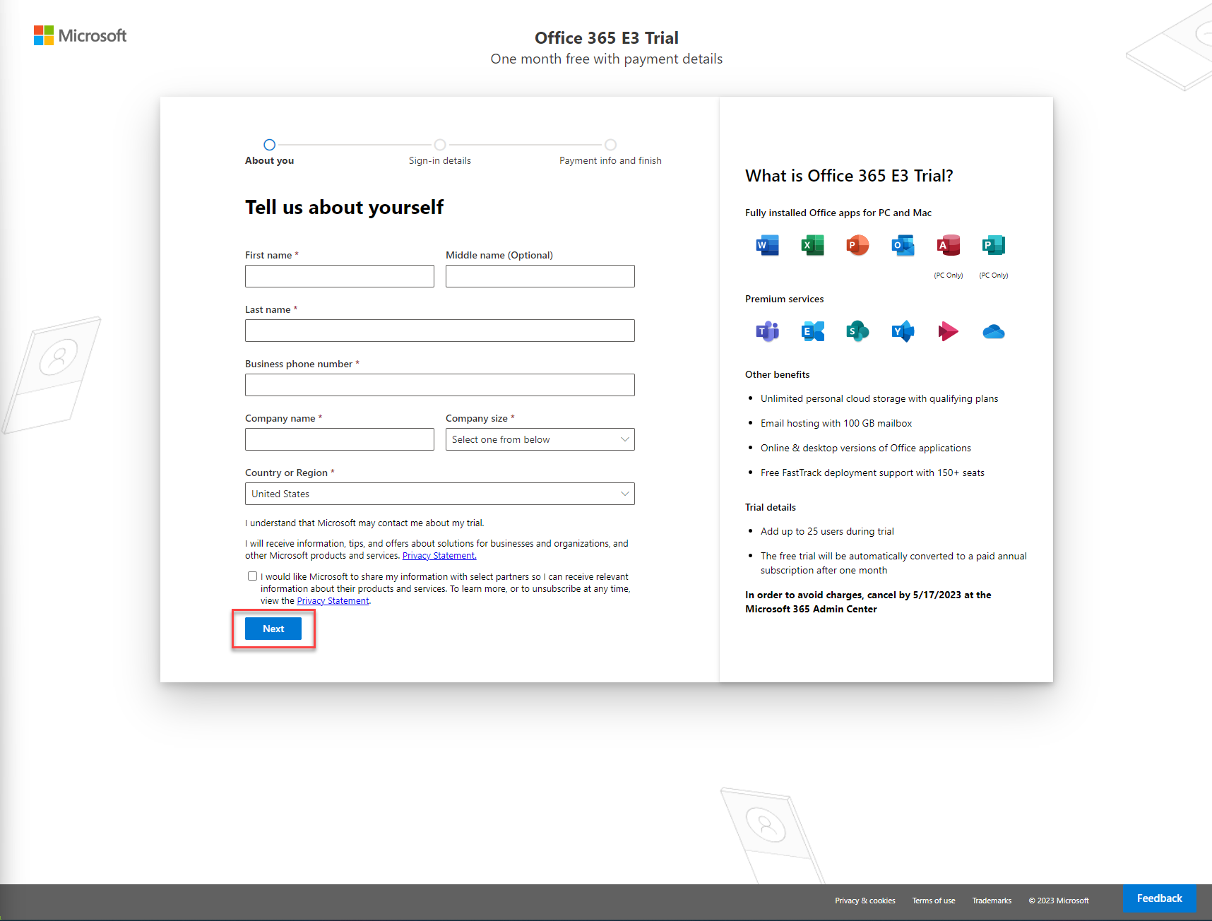

1. You’ll be asked to verify you identify using either phone call or text message. Follow directions and confirm your identity by specifying phone number.

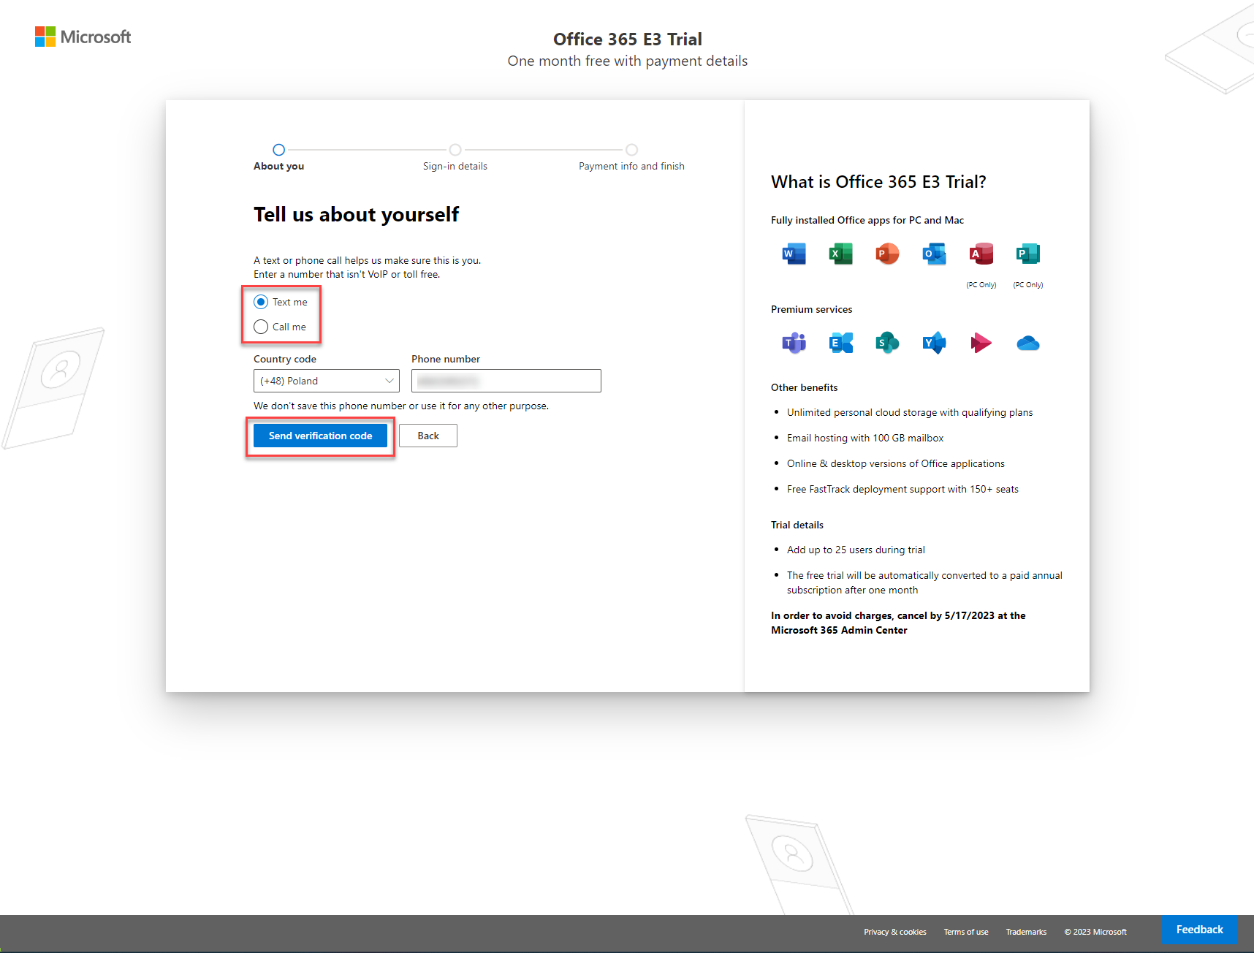

1. Once you verify your identity, you’ll be asked to provide details to let you **sign in to your demo tenant**. Click **Save** to check if the provided domain name can be used.

**Note:** you should choose your own unique tenant domain (we use yourdemocompany just as an example)

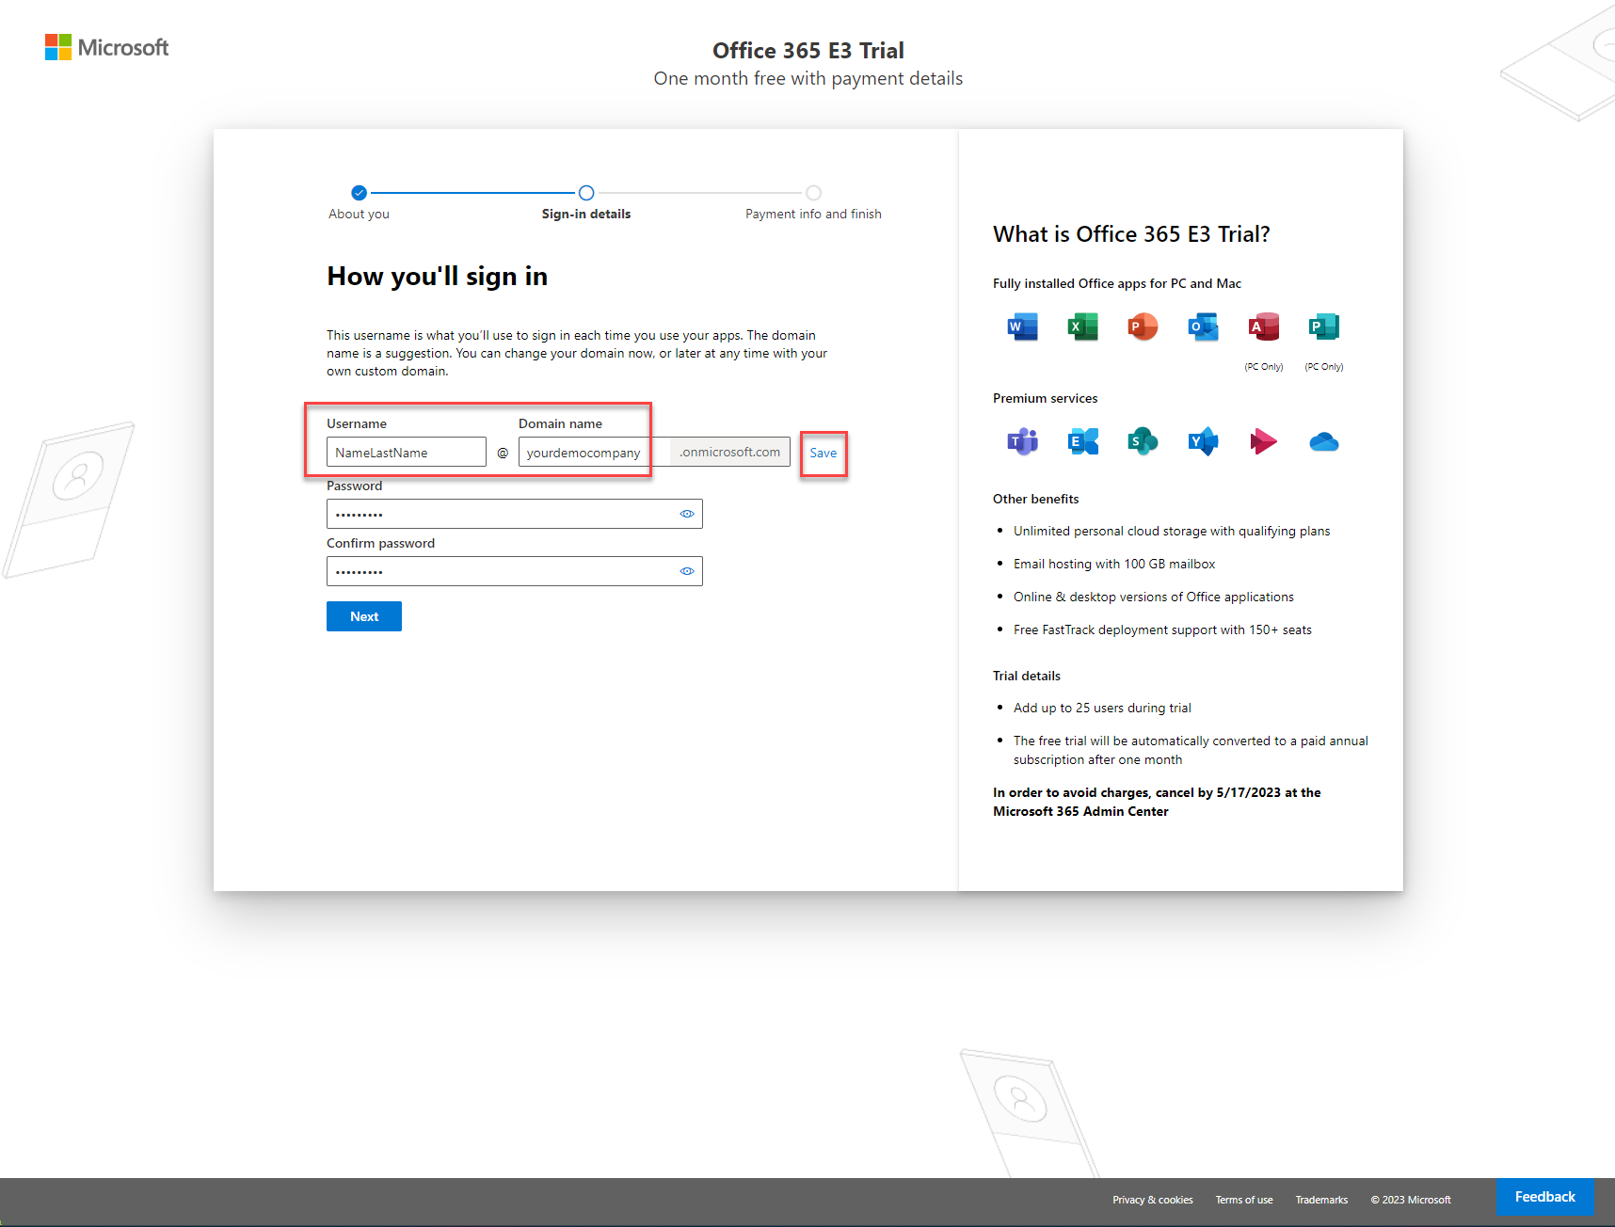

1. If the **Domain name** field is greyed out, it means that the domain name selected by you can be used. If you need, you can still change it by clicking the **Edit** link.

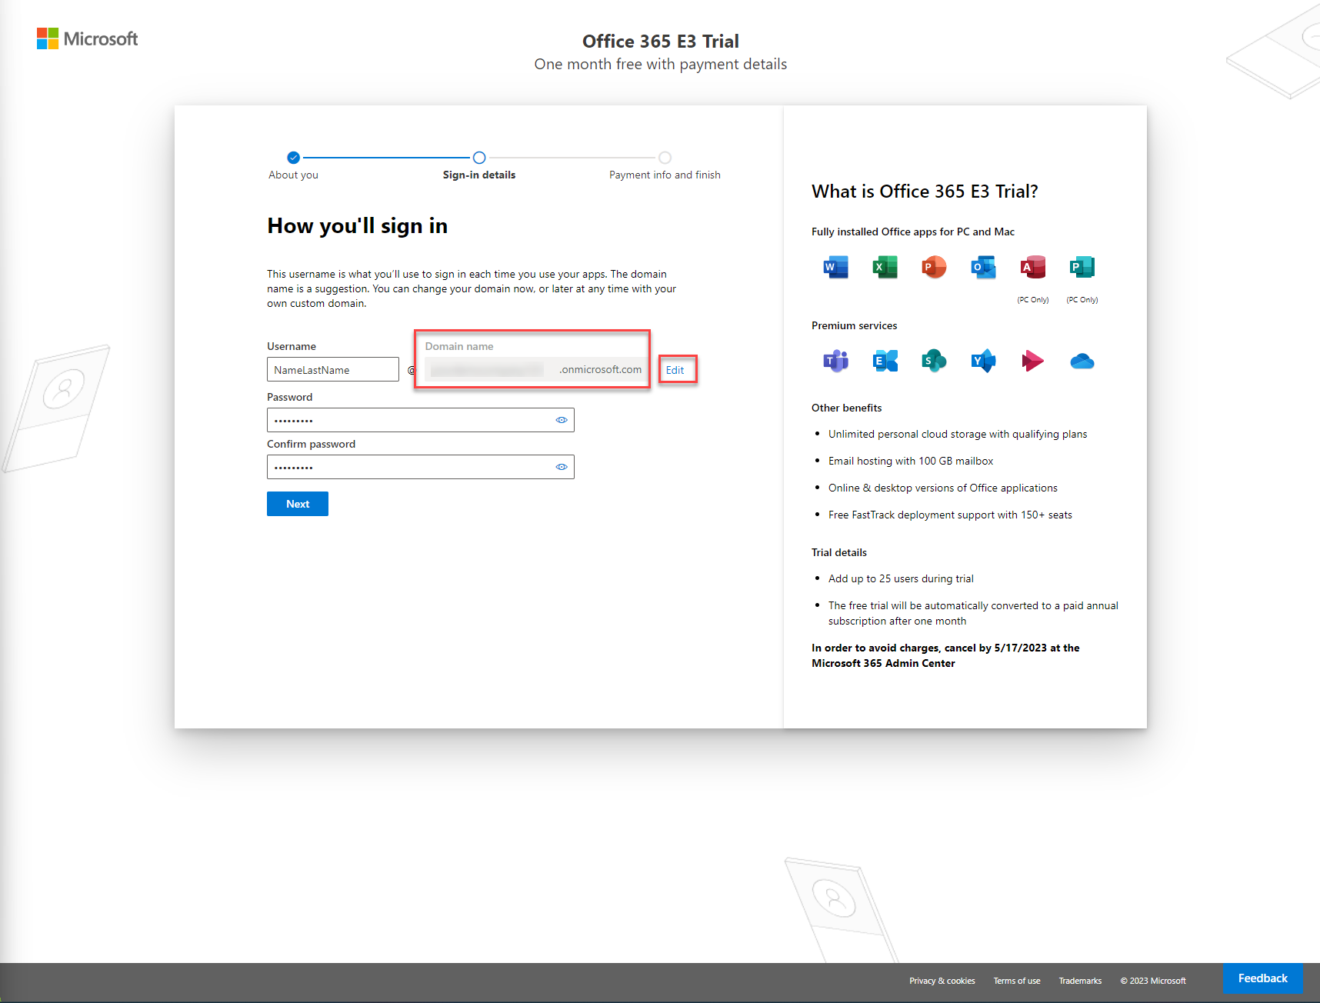

1. If the custom domain name is available, type in password and confirm it, then click **Next**.

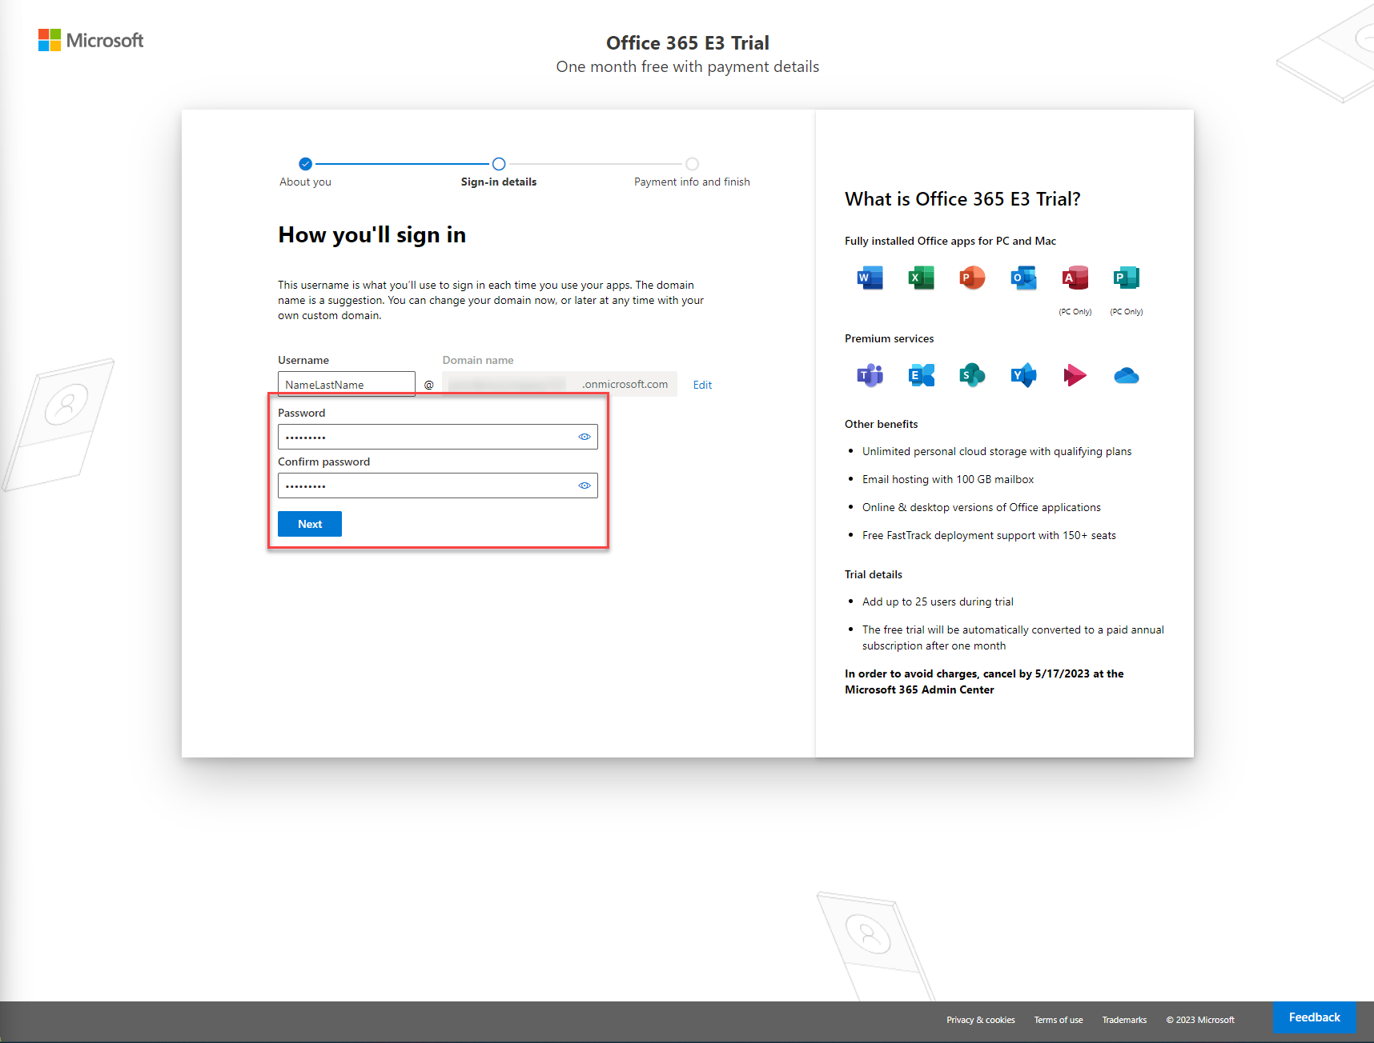

1. Wait while tenant is created. It usually takes less than 1 min. After you are signed in, hit **Add payment method** button.

**Note:** Remember to cancel the trial before it is turned into a paid annual subscription.

1. Provide your credit card details and hit **Save** button.

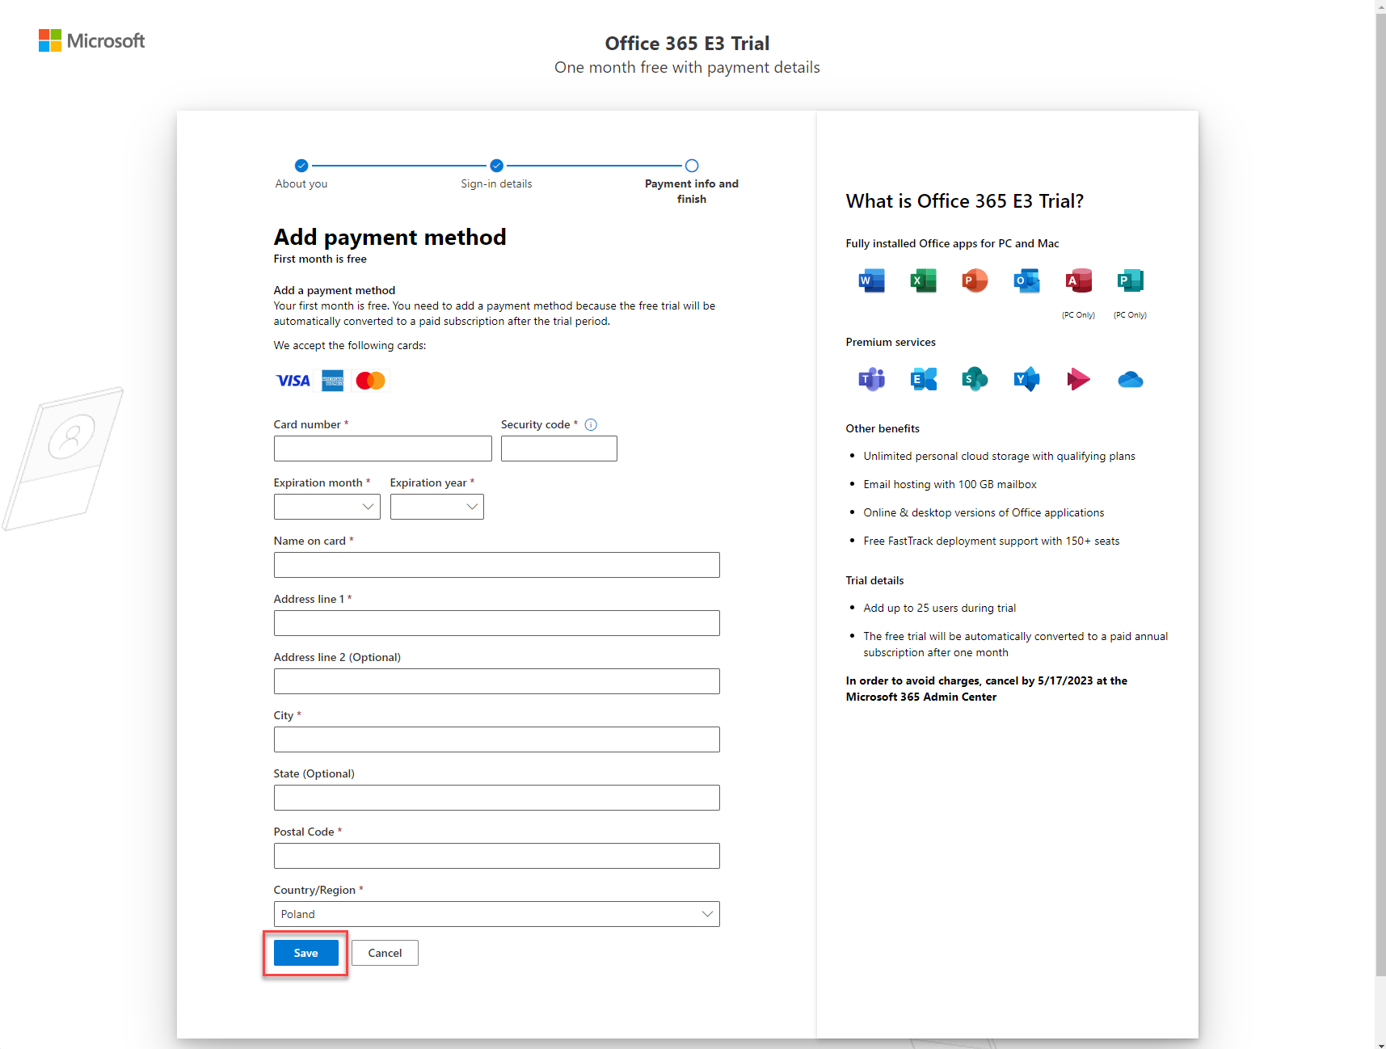

1. Next you can change the number of trial subscriptions that you would like to have with your tenant.

Additionally, if a tenant is registered with your company, you can provide its Tax ID number by clicking Add a tax ID link.

Also fill in your personal number or TIN number (although can be a fake one) and hit **Save** button.

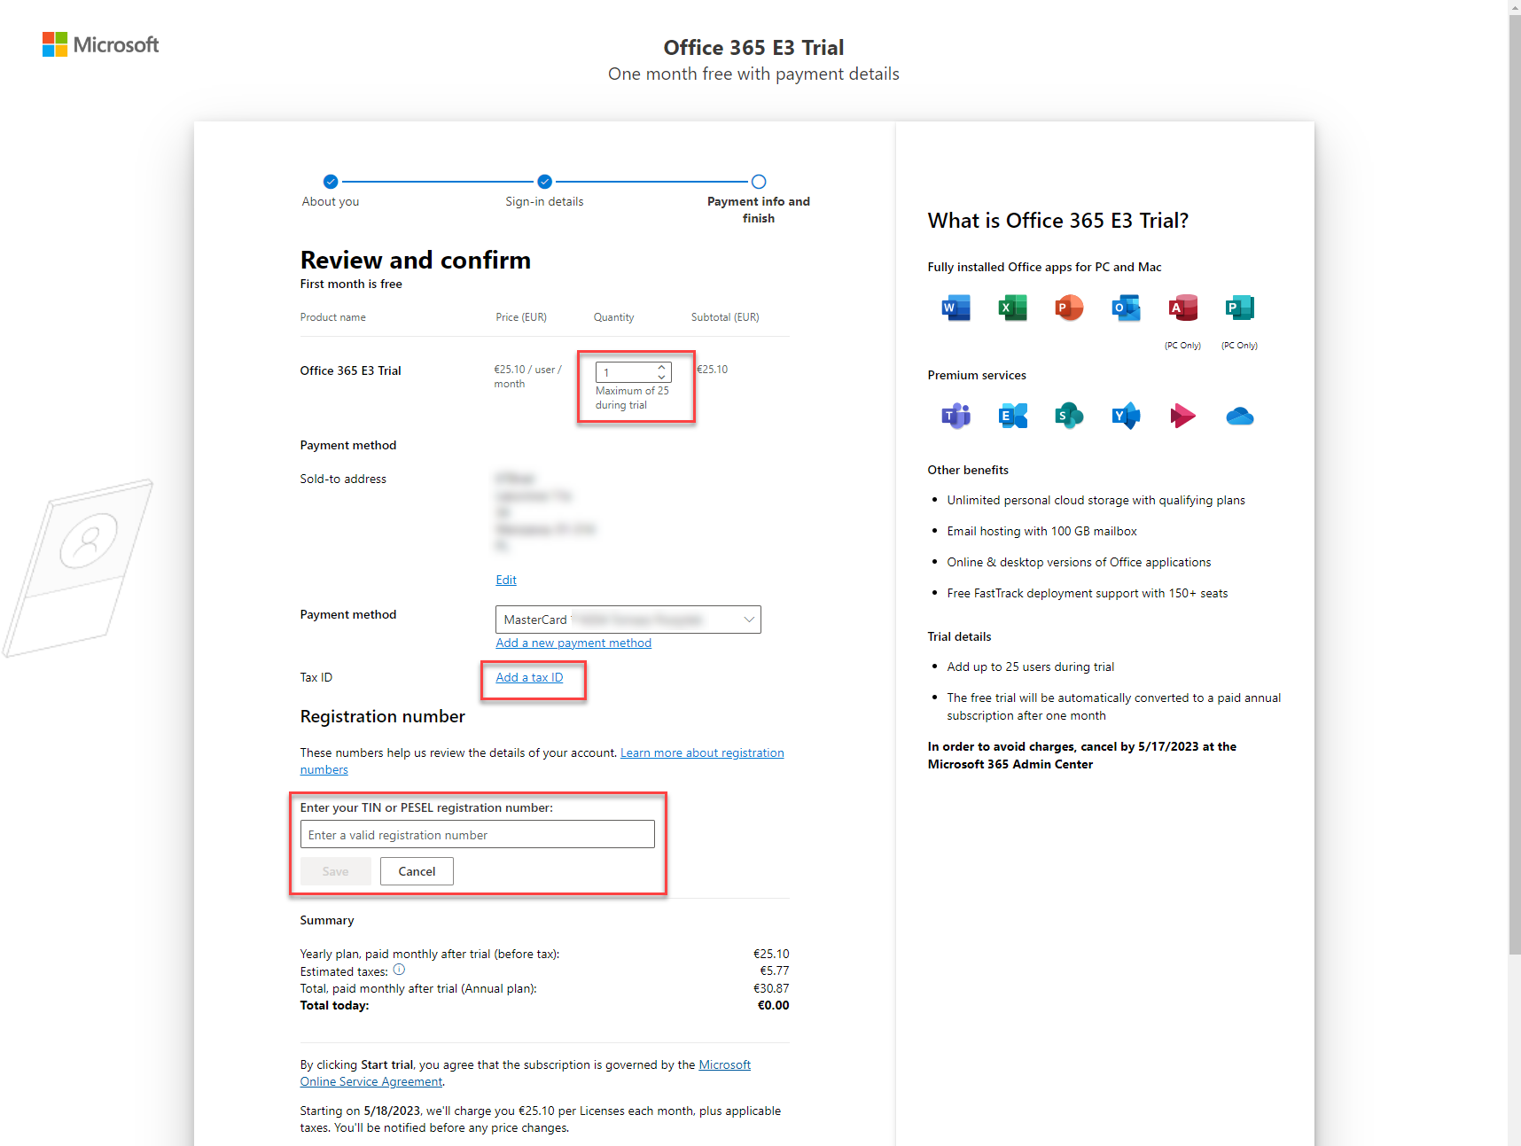

1. Next scroll down to the bottom of the page and click **Start trial** button.

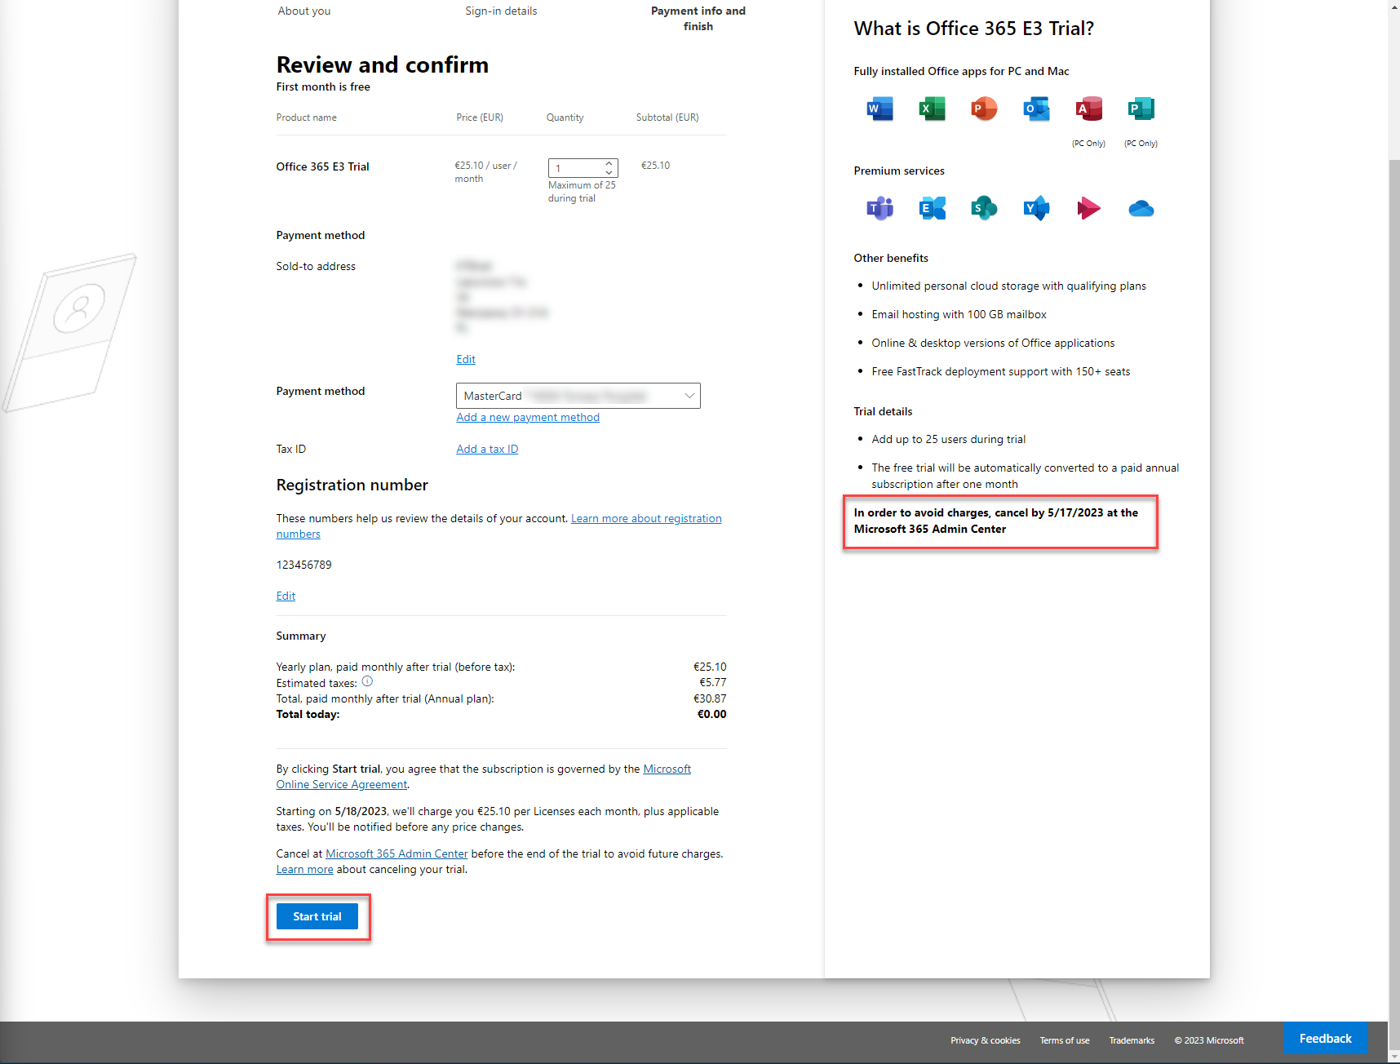

1. And you are all set! Click the Start using Office E3 Trial button to navigate to your new tenant.

**Note:** Remember to cancel the trial before it is turned into a paid annual subscription – the date is shown on the confirmation page and sent to your email address.

1. Click **Exit setup** link (in a bottom right corner).

1. Select Other as the reason for leaving setup and then click Send and exit.

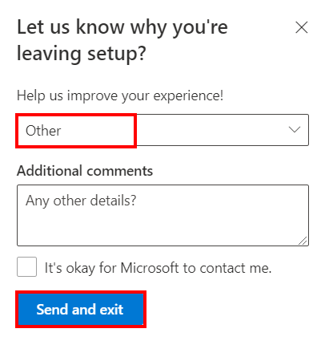

# Pre-requisite task 2: Start free Power Automate per user with attended RPA plan

1. Navigate to “Purchase services” inside your Microsoft 365 admin center: <https://admin.microsoft.com/AdminPortal/Home#/catalog> and type in “attended RPA” in the **search box**. Then click **Details** button,

1. Click the **Start free trial** link.

1. Click the **Try now** button.

1. Next click **Continue** button.

1. Now navigate to the **Active users** page: <https://admin.microsoft.com/AdminPortal/Home#/users> and click **Display name** of the account you want to assign the trial license.

1. Select **Licenses and apps** tab and select the checkbox next to the **Power Automate per user with attended RPA plan** license. Finally hit **Save changes** button.

# Pre-requisite task 3: Create a trial environment with database

Now, you’ll create a trial environment to explore Microsoft Power Automate.

Warning: When your trial expires in 29 days, your [data](https://admin.powerapps.com/) and any customizations will be [deleted](https://admin.powerapps.com/).

You may want to save your work to use in another environment. To do that, export your work as a solution after you complete all the exercises in the Robotic Process Automation in a Day training.

## STEP A: Navigate to Power Automate portal

Click the link <https://make.powerautomate.com/> to open the Power Automate portal. Select your region and click **Get started** button.

## STEP B: Sign in

Navigate to: <https://admin.powerplatform.microsoft.com/environments>

On the Environments page, sign in with the test account’s e-mail you created for this tenant domain if you’re not signed in automatically.

.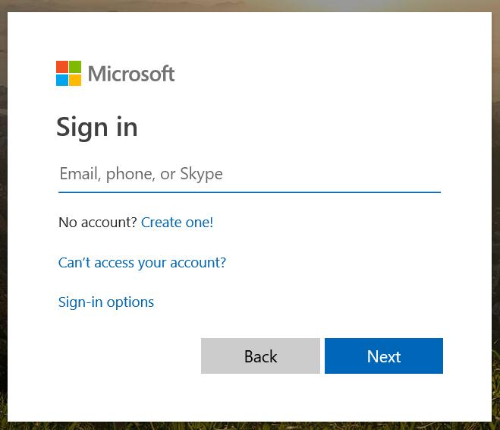

## STEP C: Configure your default environment to add a database

1. Select Environments in the tab bar (Note: you may need to expand the Left Navigation bar options to see it). Then select your automatically created environment that has “(default)” in the name.

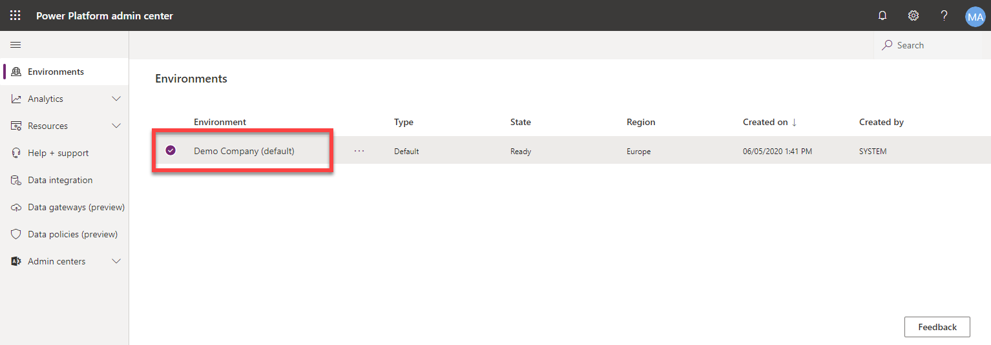

1. Select Add database.

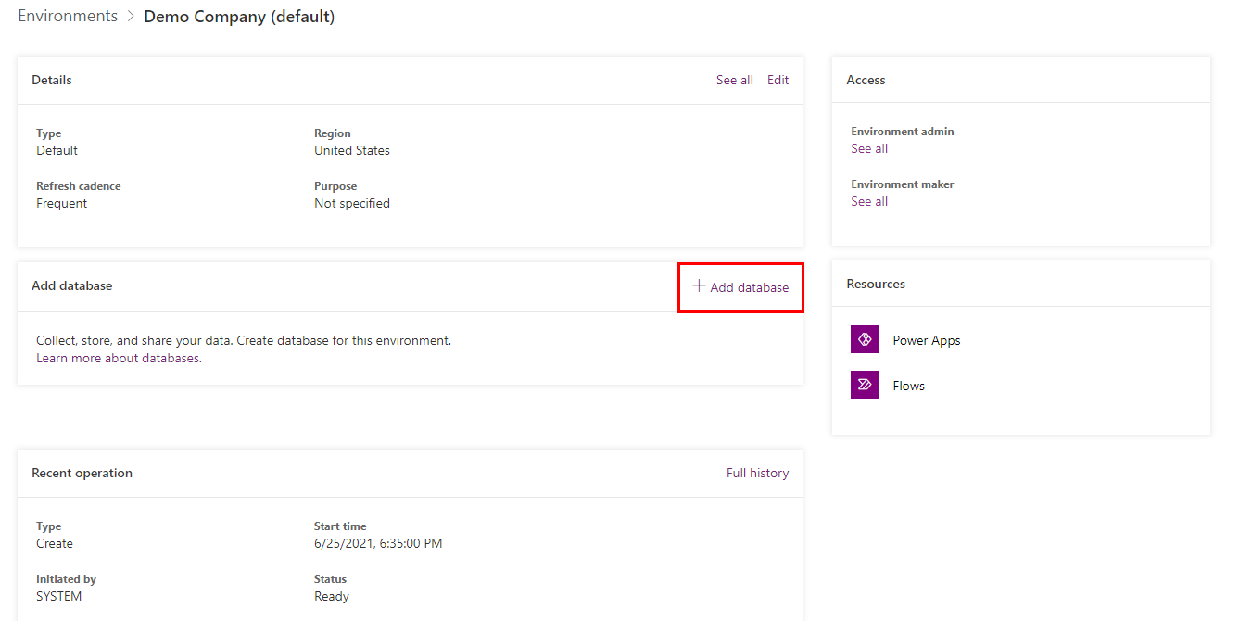

**Note:** If your environment already has a database created, you will not see this option on the page.

1. Specify values in the Create a database for this environment dialog box. Use these values:

* Language:English
* Currency: USD

Then clickAdd.

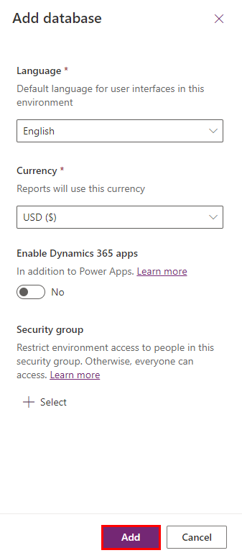

**Note:** You may be asked to sign in again.

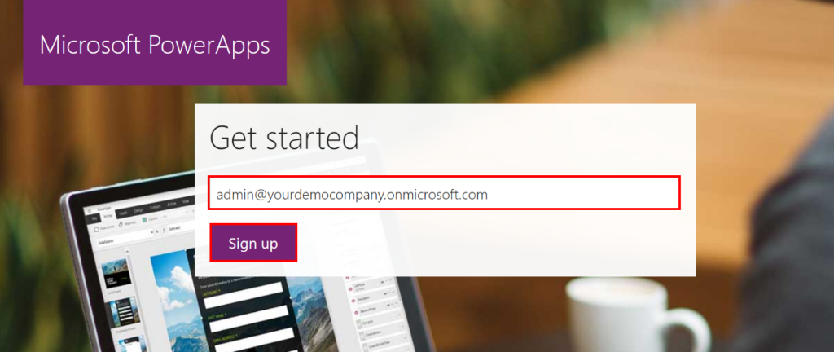

If you see the prompt of this picture below or other Power Apps signup page, just click “Trail” in the red banner, follow the instruction to sign in one more time, then repeat step above starting from Step B – navigate to <https://admin.powerplatform.microsoft.com> and repeat Create my database.

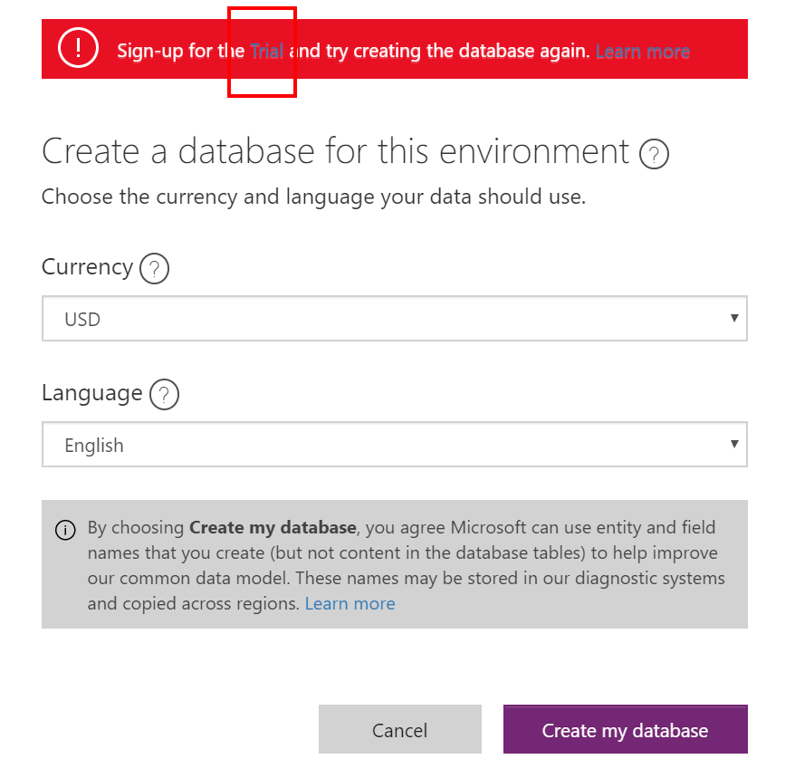

1. After you clicked the Create my database, you can see the database provisioning progress.

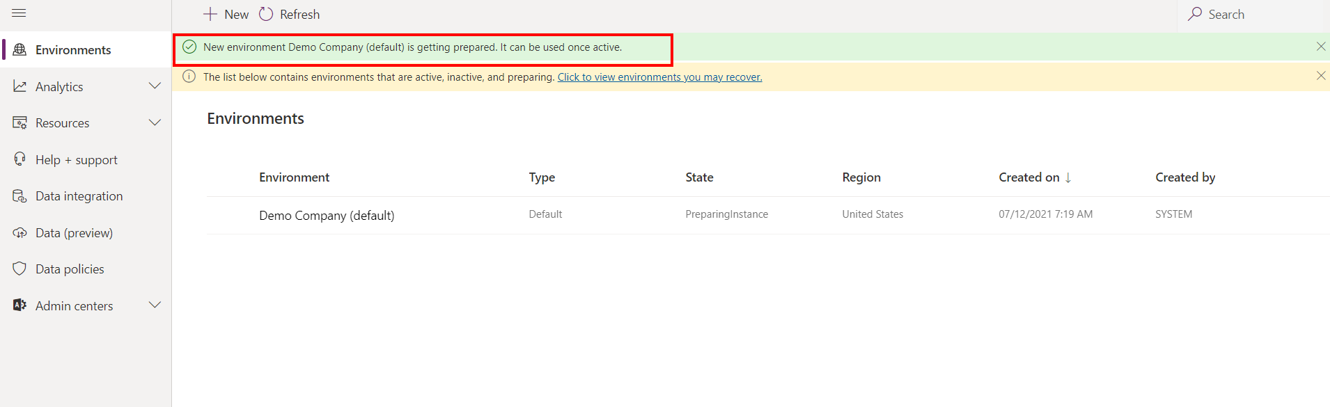

**Note:** creating a database may take up to a few minutes. Please wait or refresh until you see the “New environment is getting prepared” message disappeared.

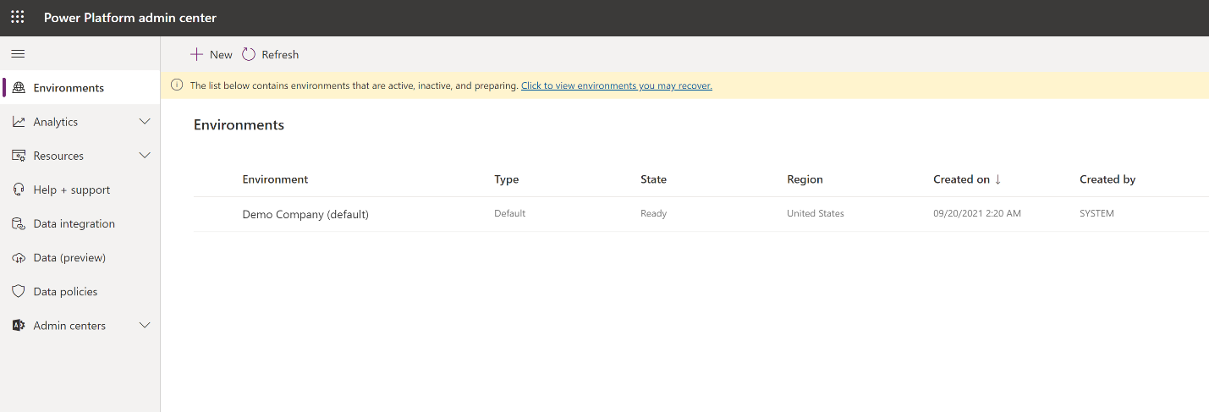

Your environment will be ready after the database is provisioned.

Once that’s done, you’re ready to go to lab #1.2.

Information in this document, including URL and other Internet Web site references,  
is subject to change without notice. Unless otherwise noted, the example companies, organizations, products, domain names, e-mail addresses, logos, people, places, and events depicted herein are fictitious, and no association with any real company, organization, product, domain name, e-mail address, logo, person, place or event is intended or should be inferred. Complying with all applicable copyright laws is the responsibility of the user. Without limiting the rights under copyright, no part of this document may be reproduced, stored in or introduced into a retrieval system, or transmitted in any form or by any means (electronic, mechanical, photocopying, recording, or otherwise), or for any purpose, without the express written permission of Microsoft Corporation.

Microsoft may have patents, patent applications, trademarks, copyrights, or other intellectual property rights covering subject matter in this document. Except as expressly provided in any written license agreement from Microsoft, the furnishing of this document does not give you any license to these patents, trademarks, copyrights, or other intellectual property.

The names of manufacturers, products, or URLs are provided for informational purposes only and Microsoft makes no representations or warranties, either expressed, implied, or statutory, regarding these manufacturers or the use of the products with any Microsoft technologies.  
The inclusion of a manufacturer or product does not imply endorsement of Microsoft of the manufacturer or product. Links may be provided to third party sites. Such sites are not under the control of Microsoft and Microsoft is not responsible for the contents of any linked site or any link contained in a linked site, or any changes or updates to such sites. Microsoft is not responsible for webcasting or any other form of transmission received from any linked site. Microsoft is providing these links to you only as a convenience, and the inclusion of any link does not imply endorsement of Microsoft of the site or the products contained therein.

© 2021 Microsoft Corporation. All rights reserved.

Microsoft and the trademarks listed at <https://www.microsoft.com/enus/legal/intellectualproperty/Trademarks/Usage/General.aspx>are trademarks of the Microsoft group of companies. All other trademarks are property of their respective owners.